

**COMPUTER NETWORKS**

**ASSIGNMENT # 1**

**http Analysis**

**Submitted by: Izza Iqbal**

**Registration no: B23F0317AI119**

**Submitted to: Dr Adnan Iqbal**

**Department: BSAI Red**

**Date: 22nd Sep 2025**

**HTTP Website Analysis:**

I have attach the file to capture http, in which I did the following steps

Steps:

1. Setting Up Wireshark for HTTP Capture
2. Accessing HTTPS Website
3. Analyzing HTTPS/TLS Traffic

**Questions:**

1. **Website Name Identification:**

* Go on the http GET request packet
* Click/Expand "Hypertext Transfer Protocol" and then find "Host:" field
* In this way you will get the domain/website name

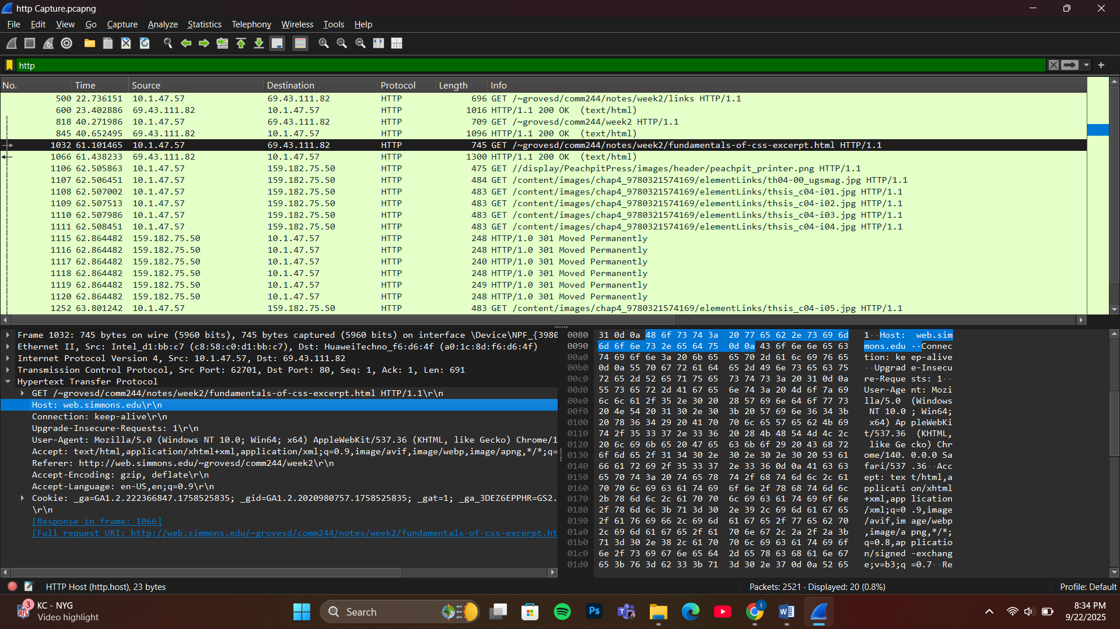

1. **First GET Request Packet Analysis:**

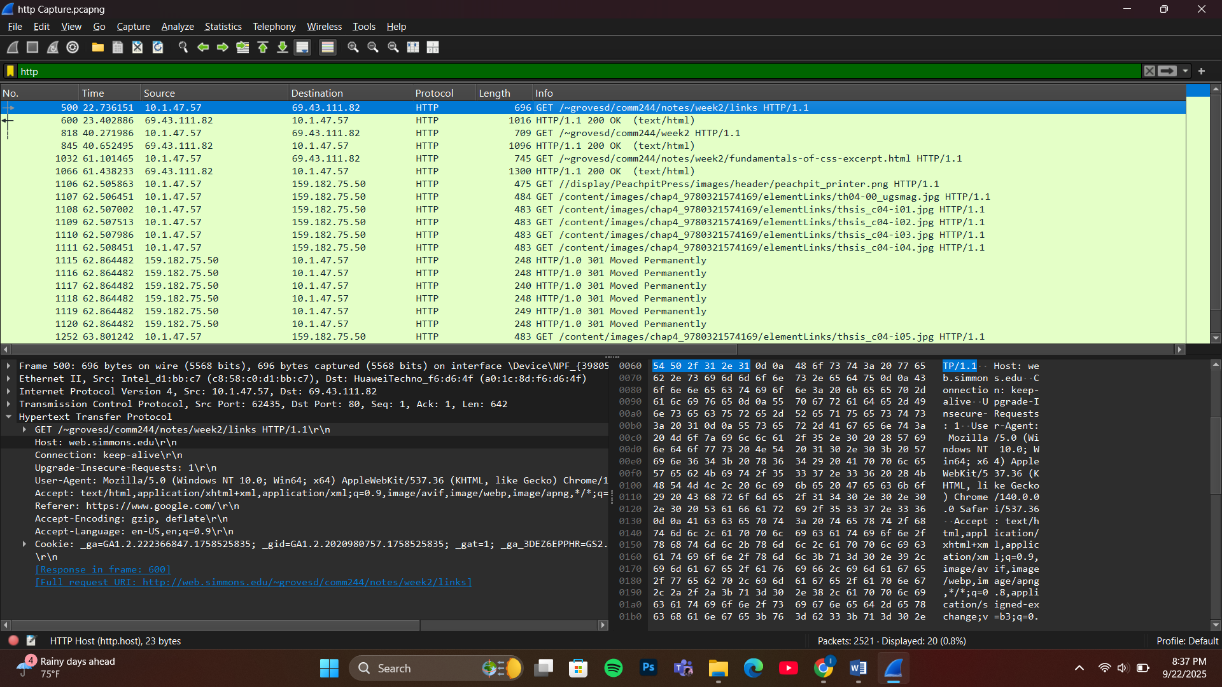

**Extract values**:

* Right-click packet → Follow → HTTP Stream
* See headers and their values in the GET request

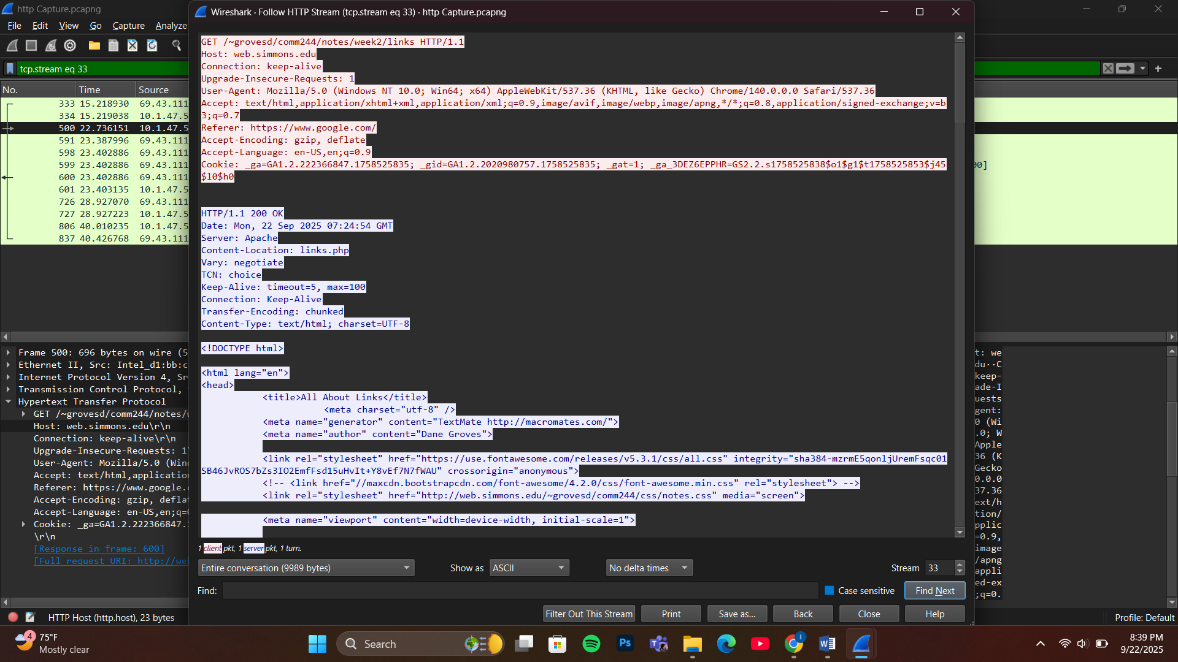

1. **Headers and Values Documentation:**

**All headers** from the GET request:

* Host
* Connection
* Upgrade-Insecure-Requests
* User-Agent
* Accept
* Referer
* Accept-Encoding
* Accept-Language
* Cookie

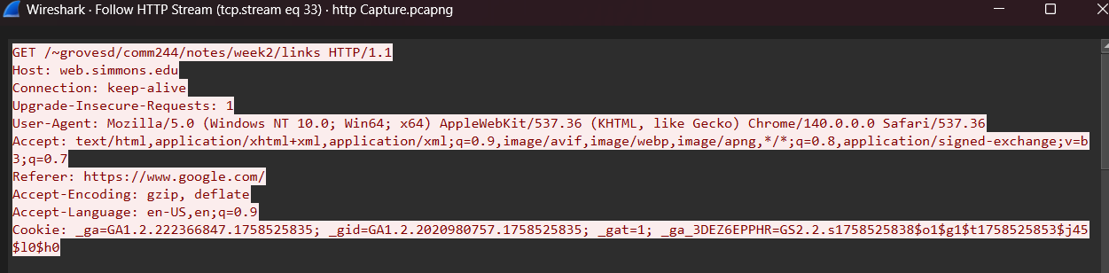

1. **Server Response Headers**

**Document headers**:

* Date
* Server
* Content-Location
* Vary
* TCN
* Keep Alive
* Connection
* Transfer-Encoding
* Content-type

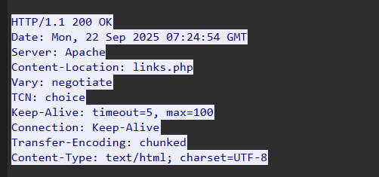

1. **HTTP Response Message Count:**

• Use filter http.response

• **Count packets = 10 packets**

This is displayed at the bottom right of the image

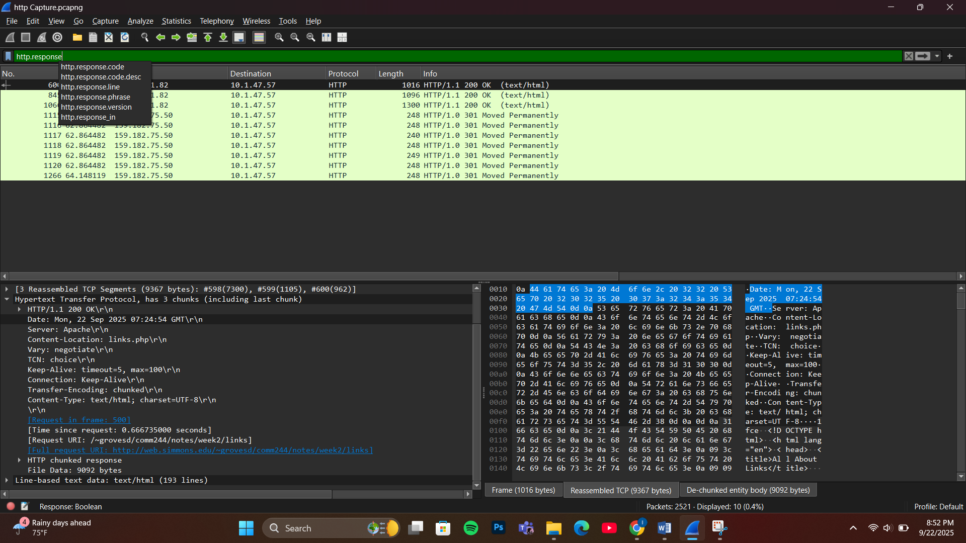

1. **Connection Persistence Analysis:**

**Persistent Connection** = Browser keeps the connection open to send multiple requests

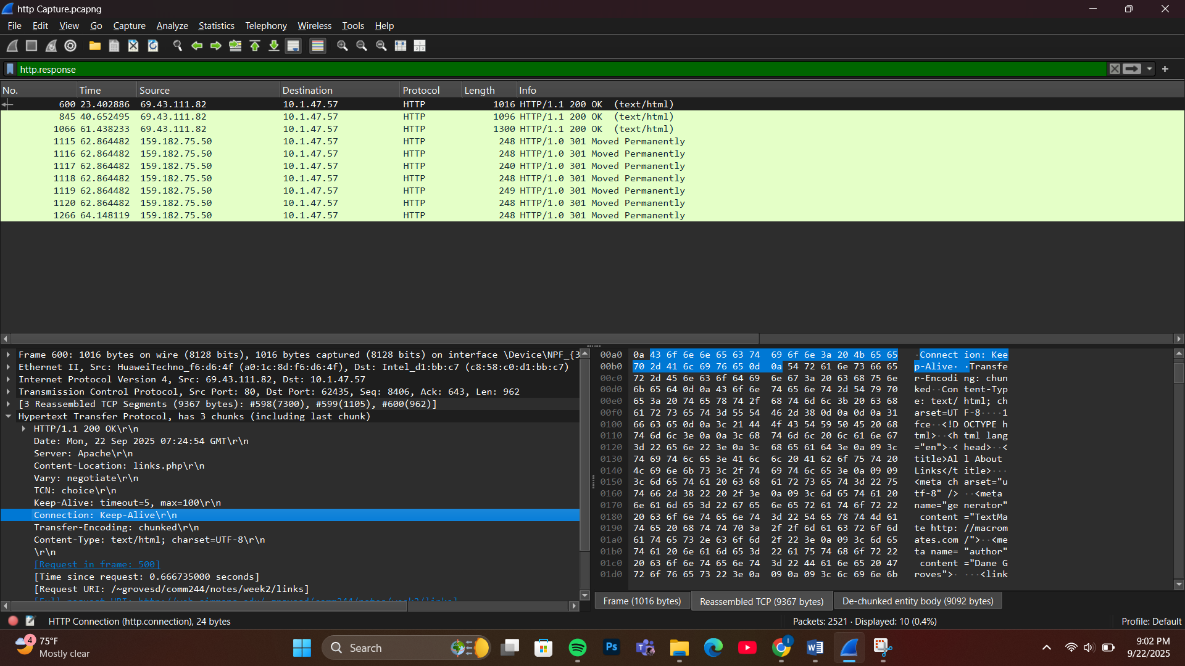

**Evidence:**

* In the HTTP GET request, the Connection header shows: Connection: keep-alive
* This means the browser will keep the TCP connection open to reuse it for multiple HTTP requests
* This is more efficient than opening a new connection for each request

**Keep-Alive: timeout=5, max=100** means:

* **timeout=5**: Connection stays open for 5 seconds after last request
* **max=100**: Up to 100 requests can use this same connection